# ACTIVITY DIAGRAM ALONG WITH ROLES OF EACH ACTIVITY

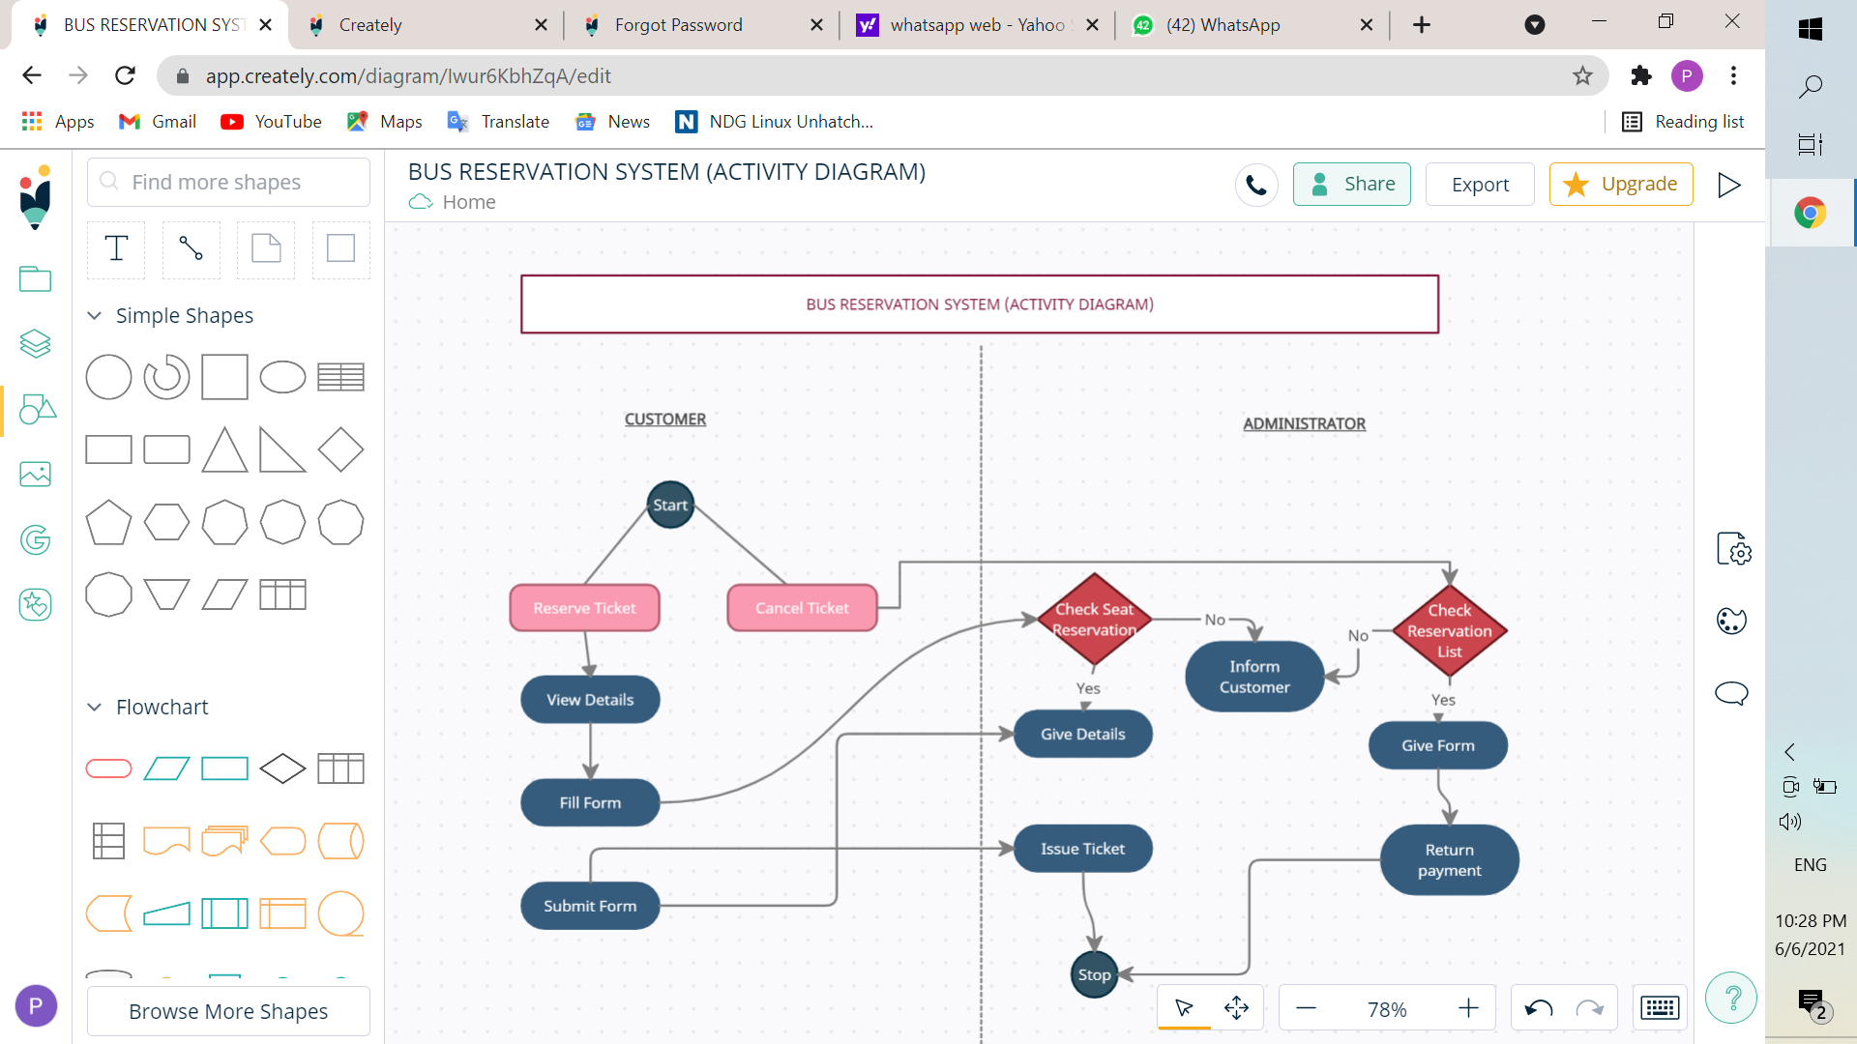

There are a total of 12 activities as shown in the above BUS RESERVATION SYSTEM Activity Diagram. They are as follows:

1. RESERVE TICKET
2. CANCEL TICKET
3. VIEW DETAILS
4. FILL FORM
5. SUBMIT FORM
6. CHECK SEAT RESERVATION
7. INFORM CUSTOMER
8. GIVE DETAILS
9. ISSUE TICKET
10. CHECK RESERVATION LIST
11. GIVE FORM
12. RETURN PAYMENT

The specifications of each role are given below:

1. **RESERVE TICKET**- This activity’s role is to reserve a new ticket for a customer.
2. **CANCEL TICKET**- This activity’s role is to cancel the user’s already booked ticket (if any).
3. **VIEW DETAILS**- This activity’s role is to let the user view his/her details. The user can view details such as the bus number, seat number, departure and destination locations etc.
4. **FILL FORM**- This activity’s role is to allow the user to fill a form regarding the bus ticket reservation. The user has to fill details such as Bus Number, Departure and Destination locations and the date of departure and confirm the payment.
5. **SUBMIT FORM**- This activity’s role is to submit the form once the user has completed the FILL FORM role as mentioned above.
6. **CHECK SEAT RESERVATION**- This activity’s role is to allow the user to verify whether the seat has been successfully reserved or not.
7. **INFORM CUSTOMER**- This activity’s role is to inform the user about the reservation of the bus ticket.
8. **CHECK DETAILS**- This role is to check all the details about particular bus, whether the seat is available in the bus, which time it departs, and from where to where it travels.
9. **ISSUE TICKET-** After successful submission of the SUBMIT FORM, user can issue the bus ticket successfully.
10. **CHECK RESERVATION LIST**- If the user details are available in the reservation list, then proceed further for cancellation of the ticket, else it’ll inform the user about the query.
11. **GIVE FORM**- If user details are there in the reservation list, then this role will provide them the form to fill for the cancellation of tickets.
12. **RETURN PAYMENT**- After successful submission of GIVE FORM, payment of the user will be refunded to them.